**DAILY ONLINE ACTIVITIES SUMMARY**

|  |  |  |  |  |  |  |  |  |
| --- | --- | --- | --- | --- | --- | --- | --- | --- |
| **Date:** | **09/06/2020** | | | | | **Name:** | **ASHISH GRACION MENEZES** | |
| **Sem & Sec** | **4&A** | | | | | **USN:** | **4AL18CS012** | |
| **Online Test Summary** | | | | | | | | |
| **Subject** | | **-** | | | | | | |
| **Max. Marks** | | **-** | | **Score** | | | **-** | |
| **Certification Course Summary** | | | | | | | | |
| **Course** | **ARTIFICIAL INTELLIGENCE IN PYTHON** | | | | | | | |
| **Certificate Provider** | | | **Great learning** | | **Duration** | | | **7 hours** |
| **Coding Challenges** | | | | | | | | |
| **Problem Statement1:Write a C program to rotate the matrix by K times** | | | | | | | | |
| **Status:Executed** | | | | | | | | |
| **Uploaded the report in Github** | | | | | **YES** | | | |
| **If yes Repository name** | | | | | **https://github.com/ash7745/lockdown-coding** | | | |
| **Uploaded the report in slack** | | | | | **YES** | | | |

Online Test Details1:No test was conducted today

Certification Course Details:”ARTIFICIAL INTELLIGENCE IN PYTHON”(continuation)

I have successfully completed the course . I have completed all the assessments with 85% of marks and I have obtained the e-certificate

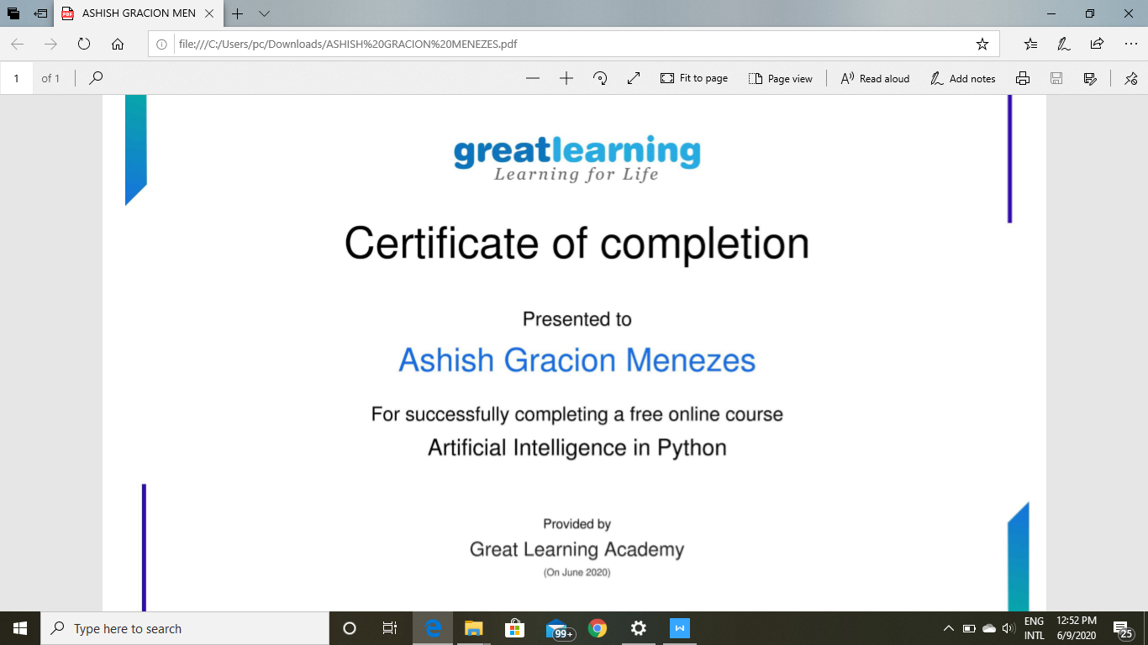

Coding details:Write a C program to rotate the matrix by K times

